Week 2:

***Task 1: What is responsive web design? Why it is important?***

***Ans:*** A responsive web design is a web design procedure which makes a website, that is it’s content adaptive to all device, screen size and window. Making contents of a website consistent across all devices, screen size and size of the browser window is very important for usability. If a website is displayed properly in smaller screens, then it is very likely that the viewers will lose interest. So, responsiveness of a website is very important.

***Task2: Webpage to demonstrate CSS to improve webpage.***

The ‘[MyPage](C:\\Users\\Moushumi\\Desktop\\Deakin study\\Introduction to responsive web app\\Weekly tasks\\Week-2\\Task 2\\Home.html)’ page demonstrates use of CSS for layout, Navigation, Color and graphics, Content, Functionality. The page is also responsive.

Screenshot of the webpage in desktop view:

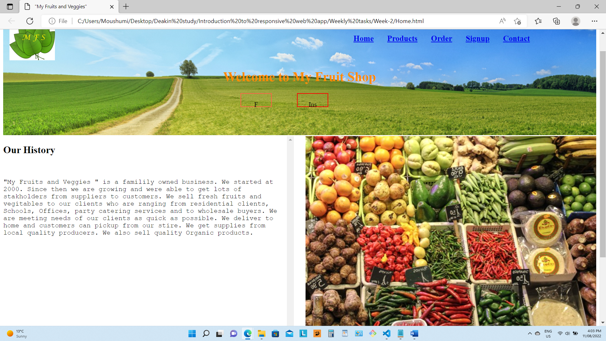

Screenshot of the webpage in mobile device:

Screenshots of the webpage demonstrates involvement of CSS in making layout, Navigation, Color and graphics, Content, Functionality, and inplementation of CSS in responsiveness.

These can be set by using % instead of px unit for images, and elements. Also setting view port togather with the %value of width, max-width etc creates responsiveness. Also flexbox, grid and multicol is helpful in this purpose. Media queries help to select CSS specific to a certain screen size od device orientation. Media queries can be based on the size of the view-port or device capability such as touch screen type of pointer etc.

***Task 3: User stories and UI/UX design for the webdesign project:***

I have a intention to produce a website for a organic grocery store who sales fruits and vegetables. They need a website with several pages, which will enable the customers make descision and buy products.

Among all pages, I am taking Home.html page and Contacts.html page as example for the UI/UX explanation.

**Page 1: Home.html -Details explanation**

This page is the home page of the website. This is linked to all the major aspect of the website by link to the pages and call for action. Also, this is linked to the social media pages of the company. This page can be described with the following user story:

***User story – Home.html***

|  |  |  |
| --- | --- | --- |
| Statement | Acceptance criteria | Priority |
| 1. As a user I want to signup/ view my account | A signup page clicking on which a login or signup window appears. | 1 |
| 1. I want to create order | A call for action button is required | 1 |
| 1. I want to send a special enquiry or make a special deal | Email popup window will be required along with a general enquiry for. | 2 |

**Page 5: Contacts.html explanation:**

This page is general enquiry form to enable the customer placing a new contract proposal or making a special order. Also, it helps the customer to find store location by a map feature.

***User story Contacts.html:***

|  |  |  |
| --- | --- | --- |
| Statement | Acceptance criteria | Priority |
| 1. I want to have a elaborate message for a new contract. | The message box should allow large number of words. Also, there should be a way to mention subject line to put the message in certain que to respond faster. | 1 |

To implement the above features the website will require use of jQuery, JSON, general JavaScript with Vue snippets, in addition to HTML and CSS. Also, to make it responsive and visually nice in very device code to create responsive like Media Query will be required.

UX/UI design:

Use of font and colour in appropriate manner is required. I will prefer natural colour of fresh products, real photographs, and video, preferably separately for different screen size. Also I prefer to use less number of HTML elements so that everything fits within small screen.

Following screenshot demonstrates responsive and use of graphics.



Caption: Desktop screenshot 1 and 2.

Caption: Mobile screen shot 1 and 2.

UI/UX design, which defines user intension is very important for creating a usable and pleasant website that will attract target users. For the website of the imaginery fruit and vegitable shop, that I intend to create website for, needs to be responsive with mobile devices of the target audience and when they will be browsing the website in the small screen, they need to view all content easily and use the functions as properly as they do the same task in their desktop screen.

Task 4 – [Use graphics, media and APIs](Task%204/Task%204.html)